

Spring 2025

We want your views on the future of Coleford

**Your regular bulletin from Coleford Town Council**



Community Newsreel

**COLEFORD TOWN COUNCIL**

are holding a consultation workshop at The Main Place on Thursday

13th March at 6.30pm and it’s your opportunity to have your voice heard!

Get involved in reviewing Coleford’s Neighbourhood Development Plan (CNDP), which will help guide and shape land use and development in the parish. FoDDC use this alongside their emerging Local Plan and the National Planning Policy Framework to decide on planning applications.

Coleford Town Council will be responsible for the final review document, but we need skills, expertise and interests of local people to create this.

The current CNDP, now seven years old, runs until 2026 so it’s now time to review and decide how we see Coleford’s future. So whether you live, work, go to school or just visit Coleford regularly we’d like you to

help create the vision of how the town might look in years to come, to shape decisions that will affect the way the town grows and flourishes.

This affects the whole Coleford area so your opinions are important if you live or are involved in any

of the surrounding villages and areas, including Coalway, Milkwall, Broadwell, Mile End, Forest Grove, Scowles and Whitecliff.

Census data over the last twenty years shows Coleford’s population grew by just eight people between 2001 and 2011, but there has been a steep rise in population since then. 2021



figures show an increase of more than 900 people, a ten percent growth in a decade; mostly as a result of extensive housing development. We will reflect on how that rapid rise in population has been dealt with locally and how to

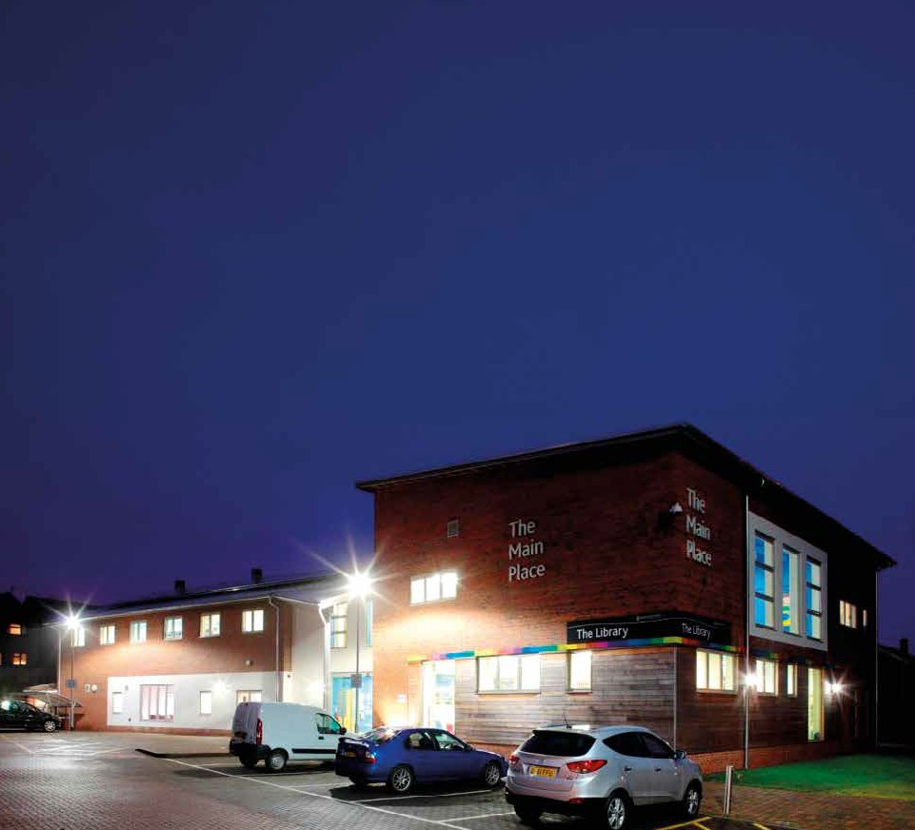

**Coleford Neighbourhood Development Plan**

**Consultation Workshop**

**Have your say on Coleford’s future development**

**Thursday March 13 @ 6.30pm**

**The Main Place, Old Station Way, Coleford GL16 8RH**

make provisions for further expansion. You can express your opinions on a whole range of issues – let us know what matters to you and listen to what affects others.

The town centre, the local economy, housing, community and community facilities, transport and infrastructure, the natural environment and historic environment are all subjects for consideration in our ever-changing community.

If you’re not familiar with the 2017- 2026 plan it can be found on the Town

* *Continued overleaf*

making a difference

* *From overleaf*

Council website at: http[s://www.](http://www/) colefordtowncouncil.gov.uk/ neighbourhood-development- plan/current-plan

There are details near the start to explain in more detail what NDPs are about.

We plan to set up steering groups and theme groups, and reach people who are just interested, who we can keep in touch with, and encourage dialogue, to make sure we are

doing our best to make plans that

improve things for everyone.

Please send your email address to [CNDPReview@outlook.com](mailto:CNDPReview@outlook.com) and we will be in touch as we progress.

If you’d like to find out more, keep an eye on this page: https:// www.colefordtowncouncil. gov.uk/neighbourhood- development-plan/cndp-review

If you are keen to be part of the process, or just interested in the future of Coleford, please come along on Thursday 13th March at 6pm to add your voice.

**Relocating TIC proves to be a good move**

Since the movement of the TIC (Tourist information Centre) we have seen an uptake in use and footfall. If you haven’t already, it is definitely worth a visit on your walk past.

As part of our Coleford regeneration project we have been busy working behind the scenes

progressing active travel, as part of this we have been looking at future planned landscaping, an up to date town centre map, funding and delivery of a new bike shelter and we are in the process of having special tiles installed to help support the use of the heritage trail and a fun thing for people of all ages to join in with and get active!

The relocation of the Town Council and TIC has been a strategic move to help and be part of the active travel corridor.

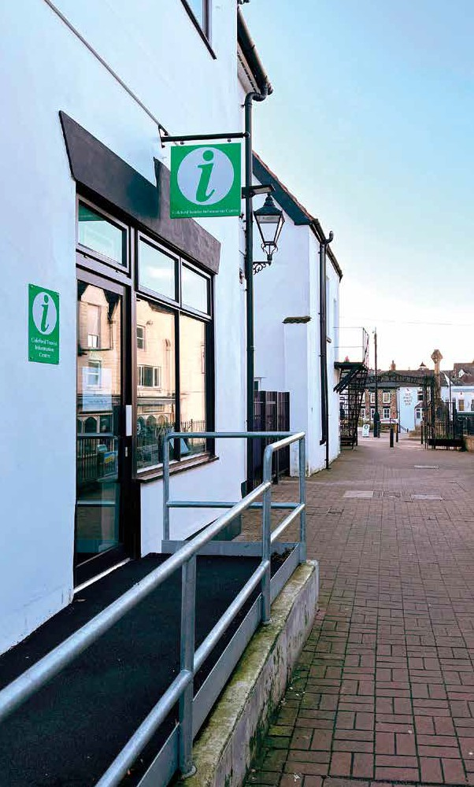If you’d like to know more get in touch.

|  |  |
| --- | --- |
| Monday | 09.30-12.30 |
| Tuesday | 09.30-12.30 |
| Wednesday | 09.30-12.30 |
| Thursday | 09.30-12.30 |
| Friday | 09.30-12.30 |

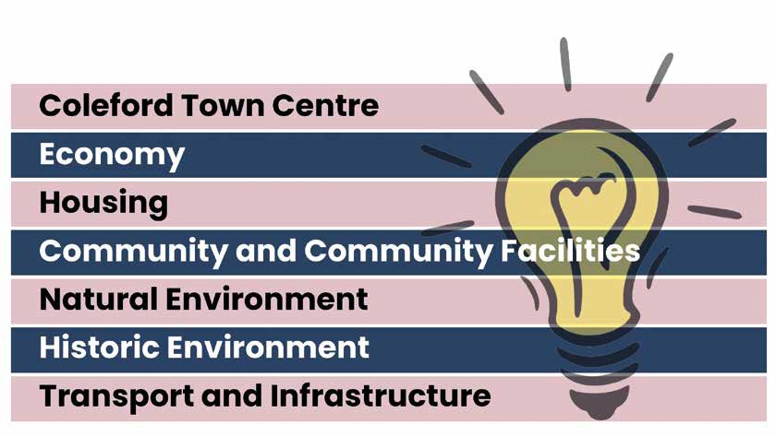

Have Your Say

Coleford Town Council would love to know what you think. If you have any issues or concerns about the town or the area in which you live please contact us or drop into Coleford Town Council offices next time you are in the town.

* + *The new TIC office in Mushet Walk*

**Contact us at:**



Scan for CNPD review page

Office opening hours

The office is not open on Bank Holidays

Hours may also vary over the Christmas holiday

**t: 01594 832103**

e: [ctcoffice@colefordtowncouncil.gov.uk](mailto:ctcoffice@colefordtowncouncil.gov.uk)

Coleford Town Council

4 Mushet Walk, Coleford, Gloucestershire GL16 8BQ Telephone: 01594 832103

Email: [ctcoffice@colefordtowncouncil.gov.uk](mailto:ctcoffice@colefordtowncouncil.gov.uk) Web: colefordtowncouncil.gov.uk